microRTS – MICROSENS Switches Merge PLC Technology with the IT World
PRESS RELEASE

Contact:
MICROSENS GmbH & Co.KG
Phone +49 (0) 2381/9452-0
Fax +49(0)2381-9452-100
info@microsens

Jessica Theyssen
Marketing Communications Manager
Phone +49 (0) 2381 9452-242
marketing@microsens.de

Hamm, 19 March 2018 – With its PLC software ‘microRTS’, MICROSENS, a euromicron subsidiary, integrates the automation layer with the network infrastructure. Installed on the Ethernet switches, the software replaces conventional PLC systems and supports IEC 61131-3-compliant programming through its ‘microSys’ engineering tool.
The virtual automation solution by MICROSENS replaces increasingly rigid, conventional automation concepts of the past with flexibly scalable software. Following its room automation integration, MICROSENS has now fully integrated the automation layer into the Ethernet infrastructure, as well. The microRTS now supports all PLC control features. After lighting, air conditioning, and security technology, industrial and building automation applications can now also be implemented directly within the IP network.
microRTS provides building planners with increased flexibility and planning reliability. By integrating the automation layer into the network, the classical sections at work are reallocated and minimised within the building plan.
Unique in the Automation Sector
In combination with the PLC runtime system microRTS, the development platform microSys represents an automation sector solution that is unique in the world. The PC-based engineering tool microSys is a software platform for the creation of control applications for industrial and building automation.
The microRTS runtime system embeds the automation layer into the switch firmware and allows companies to effortlessly combine redundant IT solutions with the flexibility of a user-programmable PLC system. This leads to future-proof approaches for security-relevant applications such as those used in smoke extraction technologies, security lighting, or stairway pressurisation systems.
Reducing Planning Costs
Design and setup of automation systems are among the biggest cost factors of modern buildings. During the investment phase, cost- and time-intensive planning steps are often very hard to calculate and are prone to errors. The new planning approach offered by MICROSENS mitigates these problems from the past and provides planners with more freedom. Merging the automation and network layers reduces both the cabling effort and the switch cabinet section, including associated installation costs.
This consistent continuation of the MICROSENS concept is also reflected on the field layer. To allow users to control field devices directly within the IP network, the corresponding modules are equipped with a Smart I/O Controller, which assumes both control and information transfer functions in the data network. Thanks to PoE+ technology, the controller is fed with data and powered through the network.
For further information, please visit our Website at www.microsens.com
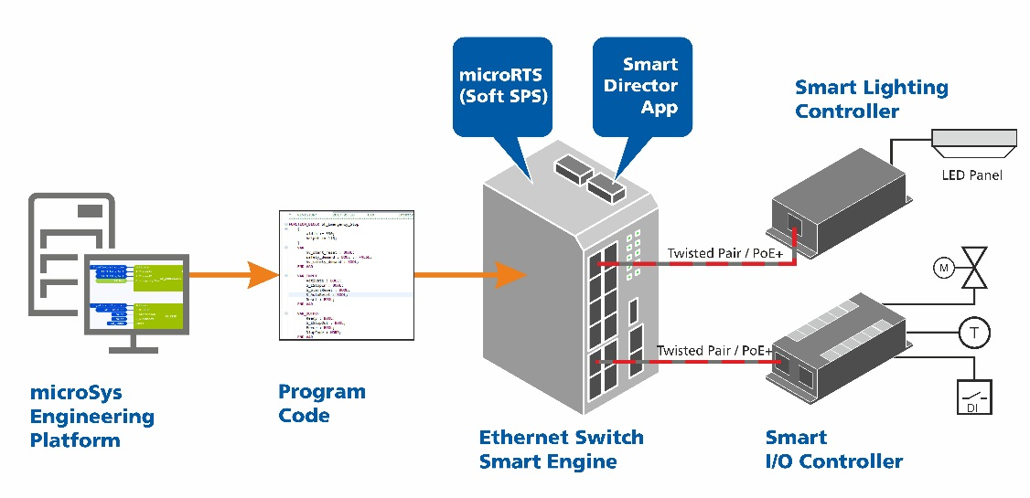

About MICROSENS
Transmitting information via fiber optic connections offers numerous benefits. MICROSENS GmbH & Co. KG recognised this very early on. As one of the pioneers, the company has developed and produced high-performance communications and transmission systems in Germany since 1993. Individually matched to the demands of diverse usage areas and embedded in comprehensive concepts for individual sectors. But, above all, close to the customer. Technical challenges from customer projects are incorporated directly into product development. This way, IP-based automation solutions are created for modern buildings, cost-efficient network concepts for the office and workspace, robust and fail-safe solutions for industrial environments, optical transport systems for future-oriented wide area networks and efficient coupling of sites and computer centres. Moreover, the companies affiliated in the euromicron group develop strategic applications and technologies for digitalized buildings, Industry 4.0 and critical infrastructures.

About euromicron:
As a company group, euromicron AG (www.euromicron.de) combines medium-scale high-tech companies from the sectors of digitalized buildings, Industry 4.0 and critical infrastructure. As a German specialist for the Internet of Things, euromicron enable their customers to network business and production processes and to successfully venture the path to a digital future. From the design and implementation over the operation up to combined services, euromicron implement customer-specific solutions and, thus, provide the necessary IT, network and security infrastructures. In this way, euromicron enable their customers to migrate the existing infrastructures to the digital age in a stepwise mode. The expertise of euromicron supports the customers of the company in increasing their flexibility and efficiency as well as in the development of new business models which set the cornerstone for the corporate success of tomorrow. The technology corporation, which has been registered at the stock market since 1998 and has its headquarters in Frankfurt am Main, employs approximately 1,800 employees at 32 company sites. The euromicron group includes 17 subsidiaries in total, among them the brands Elabo, LWL-Sachsenkabel, MICROSENS, and telent.

